Attachment A: Reading- The Causes, Course, & Consequences of the Second
Industrial Revolution in the Post-Civil War Period Reading: Adapted from “Reading Study Guide.” The Americans. McDougal Littell American Industry In 1850

In 1850, America was still predominantly a land of farms, villages, and small businesses. Fewer than 1 million people were employed in mills and factories, and the nation's annual
output of manufactured goods amounted to only 1 billion dollars. Most of the country's manufacturing was centered in the Northeast. The typical manufacturing enterprise consisted of a small plant owned and operated by a single proprietor or a group of partners, producing a limited amount of good for the local market. The Market Revolution (1815-1845) contributed to early industrialism in the United States by promoting the development of the textile industry in New England after 1815. Most of the labor in those days was done by women and children working under harsh and unsafe conditions. The factory form of production was rare before
1820, and most manufacturing was done in households, small workshops, or small mills. As late as 1820, about two-thirds of the clothing worn by Americans was made entirely in households by female family members using the "putting-out" system of manufacturing. Under this system, merchants provided family members with textile fabric, picked up the finished products, paid the workers, and distributed the clothing to nearby markets to be sold.

Later, Samuel Slater, an American entrepreneur, was the first person to bring British textile technology to the United States. As a result, the first fully developed factory was created in 1813 in Massachusetts by Francis Cabot Lowell, an entrepreneur who used Slater's ideas and introduced the British power loom into his factories. He became famous for hiring single, young, white women to work in his factories. These women came to be known as "Lowell Girls," and there is a town in Massachusetts named Lowell in honor of Francis Cabot Lowell. Lowell is remembered as the first person to develop a complete textile manufacturing business in the United States.

Industrial Growth in the United States from 1865-1900

The second half of the 19th century was a period of great industrial growth for the United States. The Civil War stimulated expansion by creating a huge demand for weapons, war supplies, farm equipment, and machinery of all kinds. After the war, the extension of railway networks and the development of the nation's coal, iron, lumber, petroleum, oil, and water resources brought industrialization to the Midwest and then to the Far West and the South. As

Page 1

a result of technical improvements and inventions, new products came into use, old industries were transformed, and new industries rose in importance.

Factors Contributing to the Second Industrial Revolution ("SIR")

The following factors contributed to the nation's rapid industrial growth: 1) wealthy Europeans and Americans eagerly invested in American industrial enterprises; 2) the 1government maintained high tariffs to protect U.S. industries against foreign competition; 3) the government maintained a policy of laissez-faire (not interfering with the economy) to promote business expansion, while at the same time providing companies with land grants, loans, and subsidies to further fuel this expansion; 4) abundant natural resources supplied industry with necessary raw materials; 5) a continuous flow of immigrants and a large population provided industry with an ample labor force; and 6) an ever-increasing population offered an expanding market for consumer goods and manufactured products.

Rise of Corporations

Small, privately owned enterprises lacked the financial resources to build huge factories, purchase expensive machinery, or extend their markets nationally and internationally. To enable companies to raise large amounts of working capital (cash), the corporate form of business came into use in the 19th century.

A corporation is a company usually owned by many people, each of whom becomes a part owner by purchasing shares of stock in the company. The stockholders then elect a
board of directors to manage the enterprise. When money is needed for expansion, additional shares may be offered for sale to the general public. Stockholders may terminate their investment in the business by selling their stock to others. Although its individual stockholders may change, the corporation itself has perpetual (continuing) life.

Corporations Combine to Form Larger Units

As corporations grew in size and wealth, a trend toward business consolidation (or combination) developed. Seeking higher profits, business leaders took steps to reduce or eliminate competition by arranging agreements with competitors to merge with one another to form a single (and larger) company. They also sought to acquire complete control, or a monopoly, of a particular industry by linking their companies with others to form

Page 2
"supercorporations." In the late 1800's, the following new forms of business combination and practices emerged:

1. Pool. A pool was an informal agreement by competing companies to fix prices, share profits, or divide the market for their products. The first pooling arrangement was made in 1870 by rival railroads in the Midwest. It soon became a common practice among other competing railroads and then spread to other industries. Because pooling agreements were not legally binding and were frequently broken, the pool system was replaced by the trust.

2. Trust. A trust was a giant business combination consisting of a number of corporations engaged in the same field or in related fields. These corporations would in many cases merge with one another to form monopolies (when a single company dominates an entire industry) or oligopolies (when two or more companies dominate an entire industry). The stockholders in the individual companies assigned their stock to the trustees and received, in exchange, trust certificates entitling each stockholder to a proportionate share of the trust's profits. In 1882, 40 companies representing 90% of the country's oil refining business established the Standard Oil Trust. Within the next decade, trusts were also formed in many other industries including the steel business.assembled into the finished the product. the idea of standardized, interchangeable parts was put forward by Eli Whitney as early as 1798 when he started manufacturing muskets.

2. Assembly Line. In this system, manufactured goods are assembled on a conveyor belt. As the belt moves along, each worker on the assembly line attached another part to the article being produced. When the product reaches the end of the line, it is complete and ready for use. The principle of the assembly line was popularized by Henry Ford in the production of the
Model-T automobile.

3. Holding Company. Starting in 1887, the courts began to rule that trust agreements were illegal, especially after the passage of the Sherman Anti-Trust Act of 1890. As a replacement, the holding company was developed. Such a company did not itself engage in the production and distribution of goods or services. Rather, it held a controlling stock interest in a number of related enterprises, called subsidiaries, and devoted itself to directing their operations. By 1900, there were 185 holding companies, representing one-third of all the
capital invested in manufacturing activities in the country.

4. Vertical Integration. Vertical Integration is a type of business organization in which a single company owns and controls the entire process from the unearthing of the raw materials, to the manufacturing and sale of the finished product. The Carnegie Steel Company was the first vertically integrated company in U.S. history. Such companies combined coal and iron mines, transportation companies, blast furnaces, and rolling mills into integrated networks. A current example is the oil industry, in which a single firm commonly owns the oil wells, refines the oil, and sells gasoline at roadside stations.
Page 3

5. Horizontal Integration. Horizontal Integration is a type of business organization in which a firm is being taken over by, or merged with, another firm which is in the same industry and in the same stage of production as the merged firm. Rockefeller's Standard Oil Company is a good example of a company that was both vertically and horizontally integrated.

Advantages of Big Business

The term "big business" is used to refer to large corporations that control major industries. Big business is able to provide the consumer with new and improved products and services at reduced prices. It can do so because it has the financial resources to 1) build modern, efficient plants, 2) acquire up-to-date, specialized machinery, 3) purchase raw materials in large quantities, 4) conduct scientific research, 5) establish a nationwide or worldwide distribution network, and 6) increase sales through advertising.

Disadvantages of Big Business

However, big business also has effects that are harmful to the economy and the consumer. It tends to 1) become monopolistic, 2) destroy competition, 3) drive out small businesses, 4) concentrate enormous wealth and power in the hands of a few, and 5) wield excessive power over government officials.
Mass Production

To make possible the manufacturing of large quantities of goods at low prices, American industry devised the techniques of mass production.

1. Standardization of Parts. The parts that make up a finished product are all of a standard size, shape, weight, etc. Machines make each part separately, and the parts are then assembled into the finished product. The idea of standardized, interchangeable
parts was put forth by Eil Whitney as early as 1798 when he started manufacturing muskets.

2. Assembly Line. In this system, manufactured goods are assembled on a conveyor belt.
As the belt moves along, each worker on the assembly line attached another part to the article
being produced. When the product reaches the end of the line, it is complete and ready for use.
The principle of the assembly line was popularized by Henry Ford in the production of the
Model-T automobile.

Pg 4.

3. Labor-Saving Machinery. Machines were perfected as a substitute for or as an aid to human labor. One machine operator could do a job that previously required the work of many workers.

4. Division of Labor. In the manufacturing process, each worker performed only one operation, making the process cheaper and more efficient, but also more repetitive. Previously, a skilled technician, working independently, produced the entire product.

New Industries Arise in the Late 19th Century

Railroads

After the Civil War, railroad construction and operation became the country's biggest business and remained such for the next 50 years. The rail network expanded until it connected all parts of the country. Short, independent lines were merged into large systems, thus making possible uninterrupted coast-to-coast passenger trips and freight shipments. In 1869, the nation completed work on its first transcontinental railroad -- a railroad that crossed the entire continent. In the years that followed, railroad tracks spread throughout the country. By 1890, more than 200,000 miles of rail lines zigzagged across the United States. The government promoted the settlement of the West by giving railroad companies land grants, loans, and pg.4
subsidies (money) to build railroads to the West. Railroads made long-distance travel a possibility for many Americans. However, building and running the railroads was difficult and dangerous work. Those who did most of the work were Chinese and Irish immigrants.
Accidents and diseases affected thousands of railroad builders each year. By 1888, more than

2,000 workers had died. Another 20,000 workers had been injured.

Railroads eventually linked the many different regions of the United States. Railroads made it easier for people to travel long distances. They also helped many industries grow. The iron, steel, coal, lumber, and glass industries all grew partly because the railroads needed their products. Railroads also increased trade among cities, towns, and settlements. This allowed many communities to grow and prosper. Railroads also led to the creation of new towns. George Pullman, for example, built a large town to house the workers he needed. Pullman
was famous for inventing lavish sleeping cars for trains. His workers eventually rebelled against him due to low wages and high rents.

The railroad industry offered people the chance to become rich. As a result, the industry attracted many corrupt individuals. In the late 19th century, railroads engaged in many abuses

Pg 5.

that caused great hardship to Western farmers and to small shippers of freight. Among these practices were 1) charging excessive rates, 2) charging more for carrying freight over short distances, where there were no competing railroads, than for long hauls in competitive territory,
3) granting rebates (refunds) to large shippers, and 4) obtaining legislation favorable to their

interests by political activity, bribery, and corruption. In response to these abuses, the Granger Movement took political action. They convinced some states to pass laws regulating railroad activity. By 1887, Congress passed the Interstate Commerce Act. The act gave the federal government even more power over the railroads by regulating their commercial practices and rates. The railroad companies, however, continued to resist all government intervention.

In 1869, Cornelius Vanderbilt became famous for consolidating a number of short railroad lines between New York City and Buffalo to the country's first great railroad system, the New York Central. It was later extended westward to the Great Lakes region and northeastward to Boston. Vanderbilt pioneered the use of steel rails, steel railroad bridges, and double tracks.

Steel

William Kelly, a Kentucky blacksmith, discovered a new method of converting iron to steel (1851). Working independently, Henry Bessemer, an Englishman, developed a similar process (1856). In the Bessemer Process, cold air is forced through molten iron to remove its impurities. Then some carbon is added to create a tough and elastic steel. The first Bessemer converter was put into operation in the United States in 1864. This process made possible the production of huge quantities of steel at low cost. Steel soon became the basic material of the economy -- used for rails, trains, machinery, wire, pipe, bridges, frameworks for buildings, ships, automobiles, and innumerable consumer products. The steel industry was originally centered in Pittsburgh, Pennsylvania but later spread to Birmingham, Alabama and to the Great Lakes region (Buffalo, Cleveland, & Chicago). Pg 5

Andrew Carnegie, called the "Steel King," dominated the iron and steel industry in the late 19th century. Operating in the Pittsburgh area, he organized a vast enterprise that produced one-fourth of the nation's steel. The Carnegie Steel Company owned not only the production facilities (blast furnaces and coke ovens) but also the sources of supply (coal fields, limestone deposits, and iron mines) and the means of transportation (railroads and ore ships) necessary for manufacturing and marketing steel. Andrew Carnegie also attempted to control the entire steel industry and became one of the wealthiest men in the world in the process.
Through vertical integration, he bought companies that supplied his raw materials such as iron

Pg 6

and coals. He also used horizontal integration by buying out or merging with other steel companies to eliminate competition. In 1900, the Carnegie Steel Company produced more steel that the entire country of Great Britain. Carnegie eventually sold his company to J.P. Morgan for 500 million dollars, making Carnegie a multi-billionaire by today's standards. Morgan later created the United States Steel Corporation, which quickly became the first billion dollar company in the world. Furthermore, Carnegie's success helped popularize the theory of Social Darwinism. This theory, based on the ideas of biologist Charles Darwin, said that "natural selection" enabled the best-suited people to survive and succeed. Social Darwinism
supported the ideas of competition, hard work, responsibility, and no government intervention in society. However, by 1889 Carnegie also supported "the Gospel of Wealth," which was the belief that wealthy people should give back and help improve society by using philanthropy (donating money) to build schools, libraries, and parks.

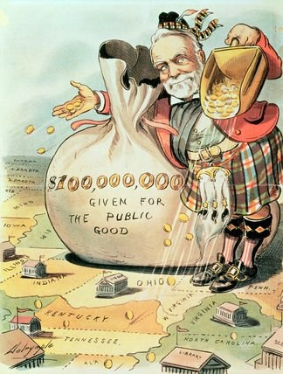

Petroleum & Oil

Edwin L. Drake in 1859 drilled the world's first successful oil well in Pennsylvania. Oil prospectors rushed to the area, and other producing wells were soon drilled. Railroad tank cars and pipelines were built to transport the oil to refineries. Here, the thick black liquid was processed into 1) kerosene, which replaced whale oil and candles for home lighting, and 2) oil and grease, which proved superior to animal fat as lubricants for machinery. These were the

Pg 7

main uses of petroleum until the development of the gasoline engine, the rise of the automobile, airplane, and petrochemical industries, and the use of fuel oil for heating.

John D. Rockefeller entered the oil refining business in the 1860's and soon became one of the nation's industrial giants. His Standard Oil Company bought out competitors or drove them out of business. He secured a monopoly, gaining almost complete control of the refining, transportation, and distribution. He hated competition (he saw it as wasteful) and sought to completely eliminate his competitors. He was so successful, in fact, that at one point the Standard Oil Company dominated 90% of the oil business. His company, like Carnegie Steel, was both vertically and horizontally integrated. Many farmers and workers across the country turned against Rockefeller because of the way that he exploited and took advantage of them. The Standard Oil Company was such a huge monopoly that it even controlled many of the same railroad companies that were accused of exploiting farmers. Eventually, the Standard Oil Company, which became the nation's first trust, was dissolved by order of the courts and was broken up into a number of smaller, independent units as a result of President Teddy Roosevelt's strong enforcement of the Sherman Anti-Trust Act (1890).

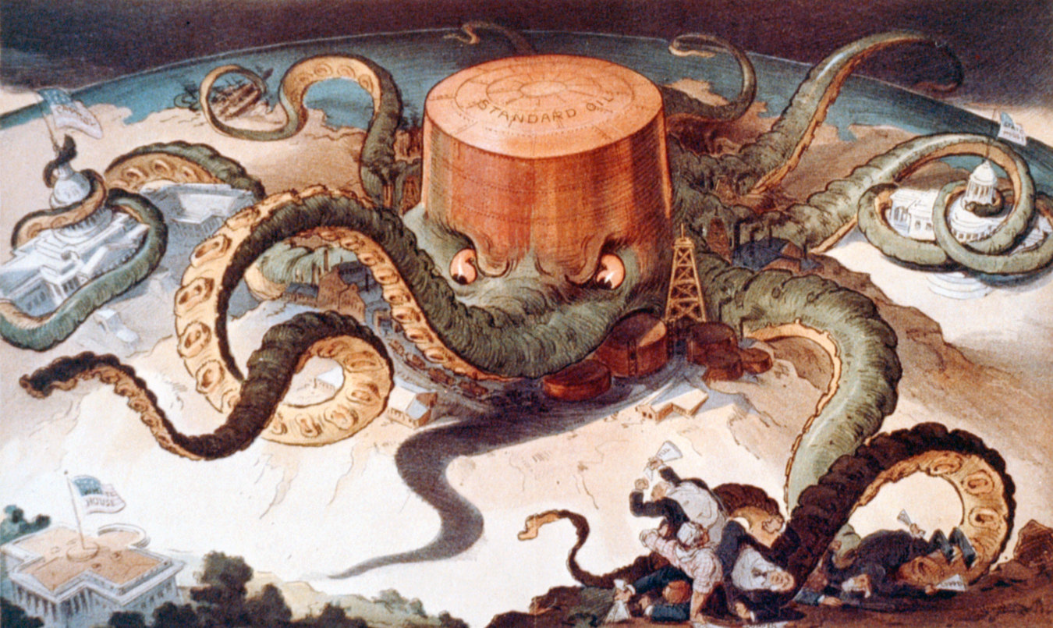

Finally, some people viewed men like Carnegie and Rockefeller as "robber barons." This was a negative depiction that portrayed these men as exploiters of working-class Americans who formed monopolies and trusts in order to become incredibly wealthy. Others viewed Carnegie and Rockefeller more positively, depicting them as "captains of industry" who promoted technology, progress, and development by moving the country forward. The truth is probably somewhere in the middle.

Pg. 8

Finance

J. Pierpont Morgan was the owner of the largest private banking and securities house in America. He reorganized many bankrupt railroads during the late 19th century. In 1901, Morgan and his associated purchased the Carnegie Steel Company and merged it with other steel producers to form the enormous monopoly known as the United States Steel Corporation. This was the nation's first billion-dollar company. Pg 7

Meat-Packing

Philip D. Armour, Nelson Morris, and Gustavus Swift were all important pioneers in the development of the meat-packing industry, which was located in Chicago and other Midwestern cities close to the cattle raising areas. Here, great numbers of pigs and cows were slaughtered and prepared for market. The waste parts of the animals were converted into by- products such as glue, soap, and fertilizer. Refrigerated railroad cars transported the meat to all parts of the country.

Tobacco

James Duke and his brother Benjamin formed the American Tobacco Company. They absorbed their competitors by threatening to ruin them through price wars. The huge tobacco and cigarette trust that they built was ordered dissolved by the Supreme Court in 1911.
Chemicals

The DuPont family started manufacturing gunpowder in Delaware in 1801. Later, the DuPont Company became one of the world's leading companies in the development and manufacturing of chemicals, dyes, plastics, and synthetic fibers.

New Merchandising Methods

Retailing Techniques Change

Before the rise of big business, people purchased their everyday supplies from either 1) a small shop, where a particular kind of product was both manufactured and sold, or 2) a general store, which sold groceries, utensils, tools, fabrics, and other goods. Foodstuffs were generally sold in bulk, rather than in packages. The needs of isolated farm families in the West were met by peddlers who drove through rural areas, their wagons stocked with wares. When

Pg 9

mass-produced products began to appear, merchants developed new types of stores and new methods of merchandising such as the following:

1. Specialty Shops. To offer a better selection of goods, stores began to specialize in a single type of product, such as groceries or hardware. Storekeepers obtained merchandise from many different suppliers.

2. Chain Stores. Enterprising merchants opened a chain of similar stores at different locations. Savings effected through large-scale purchasing and efficient management were passed on to consumers in the form of lower prices. The first grocery store chain, which later became known as the Great Atlantic and Pacific Tea Company (A & P), was founded in 1859. Frank W. Woolworth started his five-and-ten-cent variety store chain in 1879.

3. Department Stores. In these stores, goods of every description were sold under one roof. Each product category, such as women's clothing or home appliances, was featured in a separate department. Pioneers in the development of department stores included Alexander T. Stewart in New York City (1862), Marshall Field in Chicago (1865), and John Wanamaker in Philadelphia (1876). These merchants developed successful enterprises by buying goods in large quantities, selling for cash, creating demand through advertisements and marketing, and offering quality merchandise at fair prices. Pg 8

4. Selling By Mail. Mail-order selling was pioneered by two companies: Montgomery Ward (1872) and Sear, Roebuck (1895). Illustrated catalogs listing a wide variety of merchandise at reasonable prices were mailed to rural dwellers. Prospective customers studied the catalogs, chose what they wanted, and sent back their orders by mail.

5. Advertising & Marketing. Advertising in newspapers and magazines became an important means of bringing products and services to the attention of the public. In 1867, businesses spent about $50 million on advertising, and by 1900, they spent more than $500 million, and the figure was increasing rapidly. Advertisers were important in bringing producers and consumers together, thereby forging a national market.

6. Packaging. Manufacturers packaged their products in compact, distinctive containers, thus eliminating the need to cut, measure, or weigh articles being sold. Packaging also helped create brand awareness.

Pg 10

Top 10 Significant Industrial Revolution Inventors & Inventions
The Industrial Revolution that occurred in the 19th century was of great importance to the economic future of the United States. Three industrial developments led the way to the industrialization in America: (1) transportation was expanded; (2) electricity was effectively harnessed; and (3) improvements were made to industrial processes. Of all of the inventions on this list, the steam engine commercialized by James Watt was probably the most important.
The following is a list of key events and dates during the Second Industrial Revolution:

Person | Invention | Date
James Watt | First reliable Steam Engine | 1775
Eli Whitney | Cotton Gin, Interchangeable parts for muskets | 1793,  1798
Robert Fulton | Regular Steamboat service on the Hudson River | 1807
Samuel F. B. Morse | Telegraph | 1836
Elias Howe | Sewing Machine | 1844
Isaac Singer | Improves and markets Howe's Sewing Machine | 1851
Cyrus Field | Transatlantic Cable | 1866
Alexander Graham Bell | Telephone | 1876
Thomas Edison ("Wizard of  Menlo Park") | Phonograph, Incandescant Light Bulb, motion picture machine | 1877,  1879
Nikola Tesla | Induction Electric Motor | 1888
Rudolf Diesel | Diesel Engine | 1892
Orville and Wilbur Wright | First Airplane | 1903
Henry Ford | Model T Ford, Assembly Line | 1908,  1913

Pg 11

Other notable inventors and their contributions:

Peter Cooper built the first steam locomotive in U.S. history (1830). Cyrus McCormick mechanized the harvesting of wheat by developing the first mechanical reaper (1831). Samuel Colt developed the first successful repeating pistol (the revolver) in 1836. Richard Gatling perfected the rapid-fire, revolving machine gun (1862). Charles Goodyear developed the vulcanization of rubber, which made rubber more useful by preventing it from sticking and melting in hot weather (1839). George Pullman developed the first railroad sleeping car suitable for long-distance travel known as the Pullman passenger car (1859). Elisha Otis developed a practical passenger elevator in 1852. This device made possible the construction of tall building, or skyscrapers. Lyman Blake and Gordon McKay developed the shoe-stitching machine and began mass producing shoes in a factory (1858). Lewis Waterman perfected the fountain pen (1884). Christopher Sholes developed the first practical typewriter (1868). Ottmar Mergenthaler invented the linotype machine (1884), which greatly sped up the setting of type. George Eastman invented the simplified Kodak Camera (1888). Arthur D. Little developed rayon (a synthetic fabric) and artificial silk (1902). Elias Howe patented the first sewing machine and Isaac Singer developed the first commercially successful sewing machine. James Jacob Ritty invented the first mechanical cash register (1879). William Seward Burroughs developed the first practical adding and listing machine in 1892. As a matter of fact, so many inventions were developed during this time period that the U.S. government issued thousands of patents (a document that certifies that an invention has been registered with the government to protect the rights of the inventor) to American investors.

African Americans and women also made a number of important contributions to the second Industrial Revolution. Elijah McCoy, an African-American inventor, invented an oil-dripping cup for trains (1872). Other inventors tried to copy McCoy's

Pg 12

oil-dripping cup. But none of the other cups worked as well as his, so customers started
asking for "the real McCoy." That's where the famous expression comes from. MadC. J. Walker, and African-American woman, invented a hair-growing lotion for black woman to use in order to relax their hair. Walker grew up poor. But she became the
first female African- American millionaire. By 1916, she employed 20,000 African- American women across the country. Sarah E. Goode was the first African-American woman to receive a patent for her invention of the cabinet bed in 1885. Inventor Mary Anderson received a patent for her car-window cleaning device in 1903. She invented window wipers.
Consequences of Big Business

The Emergence of Political Machines

The late 1800's was the era of the "Gilded Age" in American politics. The term came from a novel written by Mark Twain in 1873 by the same name. The term Gilded Age became synonymous with an era of great wealth and prosperity but also of political and business corruption. During the late 1800's, many cities were run by a political machine. This was an organized group, headed by a city boss, that controlled the activities of a political party in a city. The machines offered services to voters and businesses in exchange for political or financial support. The bosses controlled city government, as well as jobs in the police, fire, and sanitation departments. Bosses also controlled city agencies that granted licenses to businesses, and funded construction projects. Political machines provided city dwellers with vital services. But as they gained power, many bosses became corrupt. They became rich through graft, or the illegal use of political influence for personal gain. To win elections, some bosses filled the list of eligible voters with names of dogs, children, and people who had died. They then used those names to cast votes for themselves. Another illegal practice was the kickback. Workers on city construction projects would charge a higher price for their service and then "kick back" part of the fee to the bosses, who were also taking bribes from businesses in return for allowing illegal or unsafe activities. Men like Rockefeller often manipulated this system to increase the power of their own trusts and monopolies.

One of the most powerful political bosses was William Tweed, known as Boss Tweed. He became the Head of Tammany Hall, New York City's most powerful Democratic political machine. The Tweed Ring was a group of corrupt politicians led by Boss Tweed. Thomas

Pg 13.

Nast, a political cartoonist, made fun of Tweed in newspapers Eventually, the public grew outraged by Tweed's corrupt practices Authorities broke up the Tweed Ring in 1871. Tweed and many of his followers were sentenced to prison

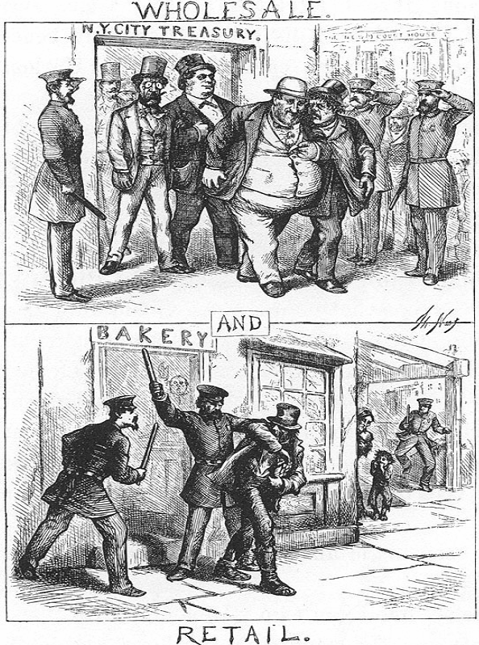

Pg 14

Labor Opposition to Trusts & Monopolies

Workers responded to the exploitation of monopolies and trusts by forming labor unions. Many workers were forced to work long hours under dangerous conditions for low wages. Women, children, and workers in sweatshops worked under especially harsh conditions. The National Labor Union was an early labor union that persuaded Congress to legalize an eight- hour day for workers in 1868. Another labor union, the Knights of Labor, worked hard to unite all workers regardless of skill, creed, gender, or race in 1879. They were very successful until they were derailed by labor riots and by disputes between skilled and unskilled workers.
Another successful labor union, the American Federation of Labor (AFL), organized only

skilled, white, male laborers under the leadership of Samuel Gompers. Formed in 1886, the AFL became the largest and most successful labor union in U.S. history by using strikes and boycotts to get better wages, shorter hours, and safer working conditions for their workers. The AFL originally started out as a union of skilled, white, male craft workers.

Labor unions used strikes (workers who refused to work until conditions improved) and boycotts (people refusing to buy products from companies that exploited workers) to improve conditions. In the late 1800's and early 1900's, however, labor's efforts to organize and better
its conditions met with violent opposition from big business. Corporations refused to recognize unions, fired employees who tried to organize workers, and hired strikebreakers to replace workers who went out on strike. The bitter labor disputes that took place during this period caused much bloodshed and destruction of property on both sides. In 1877, workers for the Baltimore and Ohio railroad went out on strike. The strike was broken up when the railroad president persuaded President Hayes to bring in federal troops to end the Great Railroad Strike, one of the bloodiest and most destructive strikes in U.S. history. Later, striking workers turned violent. The Haymarket Square Riot took place in 1886. A bomb exploded in Chicago's Haymarket Square in support of striking workers. Several people were killed, including police officers. Labor leaders were charged with inciting a riot and four were hanged,
although no one knows who actually set off the bomb. In 1892, steel workers and guards fought a battle at a factory in Homestead, Pennsylvania that left people dead on both sides. Two years later, a strike against the Pullman Car Company led by Eugene Debs and his American
Railway Union turned violent when federal troops were called out to break the strike. Over time, company owners were also able to use injunctions (a court order) to legally force striking workers to return to work.

Pg 15.

Government Action to Bring Monopolies Under Control

To curb the power of trusts, to eliminate abuses in business, and to protect the interests of the public, Congress enacted legislation and set up regulatory agencies as follows:

1. The Sherman Anti-Trust Act (1890) declared illegal any business combination (or consolidation) that sought to restrain trade or commerce. Because its wording was vague, the act was difficult to enforce against monopolies and trusts. The law was actually first used by big business to limit the power of labor unions since labor unions were perceived as disrupting
business and trade. The Sherman Anti-Trust Act did not effectively halt the growth of trusts until after the presidency of Teddy Roosevelt.

2. The Clayton Antitrust Act (1914) strengthened the power of the government in dealing with monopolies. It forbade agreements between companies to fix or control prices for the purpose of lessening competition. It also prohibited individuals from serving as directors of competing corporations.

3. The Federal Trade Commission (1914) was created to report on the activities of corporations subject to the anti-trust laws. The FTC was empowered to issue orders prohibiting unfair business practices.

Urbanization

Industrialization also contributed to the rise of urbanization in U.S. history from 1865-

1920. With the spread of industrialization, more and more people moved from rural (farm) areas to urban areas (cities and towns) where factories offered work. Urban areas also expanded because of the increasing number of immigrants who came to American after 1880 and settled mainly in the larger cities of New York, Boston, Philadelphia, and Chicago. The number of urban centers with a population of 8,000 or more increased from 141 in 1860 to about 3,000 today. Cities with a population exceeding 100,000 rose from 19 in 1880 to 192 in
1990. Furthermore, by 1900, there were six American cities with populations of over 1 million people (most of them populated by new immigrants from southern and eastern Europe), including New York, Chicago, and Philadelphia.

The most serious problems to arise from the growth of large cities were overcrowding, diseases, and the spread of slums. Slums were city areas where thousands of poor American and immigrant families lived in overcrowded and poorly constructed apartment buildings known

Pg.16

as tenements. These tenements frequently lacked fresh air, sunlight, and proper sanitation facilities. They afforded their tenants little privacy. They were subject to fires and other hazards. Children had no place to play except on littered streets, teeming with people and vehicles. Many of the tenants were too poor to feed or clothe their families properly or to obtain adequate medical care. Slum conditions led to the spread of disease and encouraged drunkenness, drug addiction, and crime.

Origins of Progressivism

One final consequence of industrialization in the late 19th century was that it gave rise to the Progressive Movement from 1890-1920. Progressivism was a movement to improve American life by expanding democracy and achieving economic and social justice for all Americans. Progressives worked very hard to improve some of the terrible conditions caused
by industrialization and urbanization. They were generally middle-class, urban reformers who were optimistic and forward-looking. They generally did not seek to restore the rural America of the past, but rather accepted industrialization and urbanization as the future of the country. Progressives hailed the benefits of the machine age but sought to correct and reform its evils. Shocked by the sorry state of everyday politics, progressives sought to wipe out graft, political machines, corruption, and business domination of government. They also sought to set up political procedures to assure the people closer control over the government. Appalled by the poverty afflicting many Americans, Progressive reformers also sought to eliminate practices hurting farmers, workers, city people, and consumers. Finally, they sought to expand government regulation over the economy so as to further protect the public interest. This marked an important transition in the role of government in U.S. history from laissez-faire to more government intervention.

Pg 17.

